Contents

AI, ML AND DEEP LEARNING 3

TYPES OF AI 5

COMPONENTS OF AI 5

HISTORY OF AI 6

WHAT IS MACHINE LEARNING 7

MACHINE LEARNING TERMINOLOGIES 8

DEEP LEARNING 9

EXAMPLES 9

ADVANTAGES OF DEEP LEARNING 10

REINFORCEMENT LEARNING 10

GENERATIVE AI 11

NLP(NATURAL LANGUAGE PROCESSING) 11

CONVENTIONAL (PREDICTIVE) AI VERSUS GENERATIVE AI 13

MACHINE LEARNING MODEL 14

MACHINE LEARNING PROCESS 15

MACHINE LEARNING MODEL AND DATASET 16

DATA SET 16

TRAINING SET AND TEST SET 17

FEATURES AND LABELS 19

DEEP LEARNING ARCHITECTURE 20

DIFFERENT ARCHITECTURE OF DEEP LEARNING 21

RECURRENT NEURAL NETWORKS (RNNS) 21

CONVOLUTIONAL NEURAL NETWORKS (CNNS) 21

TRANSFORMER ARCHITECTURE 21

FOUNDATION MODEL 23

KEY CHARACTERISTICS 23

APPLICATION OF GEN-AI 24

GEN-AI USE CASES 25

GEN-AI LIMITATIONS & CHALLENGES 25

TYPES OF ML MODELS 26

TRADITIONAL MACHINE LEARNING MODELS 26

REPRESENTATIONAL (OR REPRESENTATION LEARNING) MODELS 27

CHOOSING THE RIGHT ML SOLUTION 27

HOW MACHINE LEARNS 28

SUPERVISED LEARNING 29

CLASSIFICATION (BINARY CLASSIFICATION) 31

REGRESSION ALGORITHM 32

UNSUPERVISED LEARNING 34

SUPERVISED V/S UN-SUPERVISED LEARNING 35

SPECIALIZED ML PROBLEMS 36

RECOMMENDATION SYSTEMS 37

TYPES OF RECOMMENDATION SYSTEMS 37

ASSOCIATIONS RULES DETECTION 39

REINFORCEMENT LEARNING 40

APPLYING ML IN COMPLEX DATA 41

APPLYING ML TO TEXT DATA 41

ENCODING TECHNIQUES 42

APPLYING ML TO IMAGE DATA 44

APPLYING ML TO SPEECH DATA 44

# AI, ML AND DEEP LEARNING

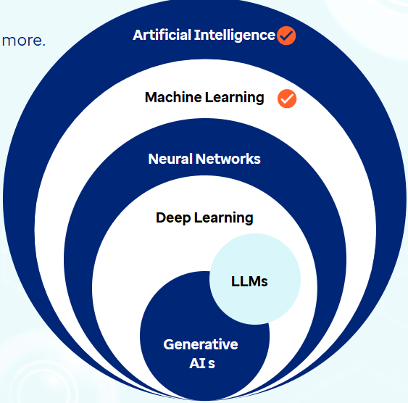

Artificial Intelligence

* A broad field in computer science, encompassing a variety of technologies that work together to enable machines to think, act, and learn in ways that mimic human intelligence.

Machine Learning

* It is a key subset of AI that focuses on training algorithms to learn from data and make decisions based on that knowledge. It allows machines to identify patterns and make predictions.

How Machine Learns?

|  |  |
| --- | --- |
| Learning Type | Description |
| Supervised learning | * Training the model on labelled data |
| Unsupervised learning | * Working with unlabeled data to find hidden patterns |
| Semi-supervised learning | * Mix of both labelled and unlabeled data |
| Self-supervised learning | * Models sequentially generate their own labels from input data to learn patterns and features. * Large Language Models are based on this technique |
| Reinforcement learning | * Agent learning by interacting with an environment and receiving feedback; improves performance based on positive reinforcement and penalizes areas where negative feedback is received |

Neural Networks

* It is a subset of ML that is inspired by the structure of human brain.
* The networks consist of layers of interconnected 'neurons' or nodes, each processing inputs and passing results to the next layer.
* ***Neural networks are designed to model complex non-linear relationships within data by adjusting the weights of these connections as they process information.***

Deep Learning

* It is an advanced subset of neural networks used to analyze and learn from vast amounts of unstructured data like images, videos etc.
* The 'deep' in deep learning refers to the multiple layers in a neural network.

|  |
| --- |
| **While a basic neural network might have three layers (input, hidden, and output), deep learning algorithms utilize many more hidden layers, allowing them to process and understand much more complex patterns in data.** |

* For example, deep learning excels in tasks involving unstructured data like images, text, or audio, by allowing **multi-dimensional input data** to efficiently recognize patterns across multiple layers in a way that traditional machine learning methods cannot.

|  |
| --- |
| **Multi-dimensional input data** refers to data that has more than one feature or attribute, often organized in a structured format like arrays, matrices, or tensors. In the context of **deep learning**, this is crucial because models need to process complex data types like:  Examples of Multi-Dimensional Input Data:  **1. Images**   * Represented as 3D arrays: **Height × Width × Channels** * Example: A 256×256 RGB image → shape: **(256, 256, 3)**   **2. Text**   * Represented as sequences of word embeddings or token vectors. * Example: A sentence of 10 words, each represented by a 300-dimensional vector → shape: **(10, 300)**   **3. Audio**   * Represented as 2D spectrograms or 1D waveforms over time. * Example: A 5-second audio clip sampled at 16kHz → shape: **(80,000, 1)**   **4. Video**   * Represented as 4D arrays: **Frames × Height × Width × Channels** * Example: A 10-second video at 30 fps, 128×128 resolution → shape: **(300, 128, 128, 3)** |

Generative Ai

* A type of AI that can **create new content—like text, images, music, or code**.
* It learns patterns from existing data and uses that to generate new, similar content.
* Examples: Writing a poem or story, Creating artwork from a text prompt, Generating music or voice etc..

Large Language Models (LLMs)

* A subset of GenAI focused specifically on language. They understand and **generate human-like text**.
* **Examples**: Chatbots (like ChatGPT); Auto-completing emails;Translating languages;Writing code
* Within deep learning, two significant subsets are
  + **Large Language Models (LLMs)** and
  + **Generative AI (GenAI).**
* LLMs, like GPT-3.5, GPT-4, and Google Gemini, are advanced AI models designed to understand, generate, and interact with human language.
* These models are called 'large' because they are trained on massive amounts of text data, containing billions or even trillions of parameters.
* These models excel at natural language processing tasks, including text generation, summarization, question answering, and code generation by **leveraging deep neural network architectures like transformers and encoders.**

## TYPES OF AI

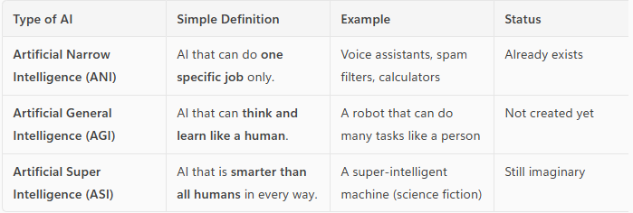

## COMPONENTS OF AI

|  |  |  |
| --- | --- | --- |
| Perception   * AI’s ability to **sense the world** using data from cameras, microphones, sensors, etc. * *Example:* A self-driving car “seeing” a stop sign using a camera. | Learning   * AI’s ability to **learn from data or experience** to improve its performance over time. * *Example:* A music app learning your favorite songs and suggesting similar ones. | Knowledge   * The **information and facts** that AI stores and uses to make decisions. * *Example:* A medical AI system storing information about diseases and treatments. |
| Reasoning   * AI’s ability to **think logically** and solve problems using the knowledge it has. * *Example:* A chess AI figuring out the best move to win the game. | Planning   * AI’s ability to **set goals and decide steps** to reach them. * *Example:* A robot planning the best path to clean a room without missing spots. |  |

## HISTORY OF AI

Classical AI (Symbolic AI)

* Classical AI, also known as **symbolic AI**, emerged in the 1950s–1980s.
* It focused on using **explicit rules and logic** to represent knowledge and solve problems.
* It was based on the idea that intelligence could be achieved by manipulating symbols according to formal rules.

Key Features

* Rule-based systems
* Logic programming (e.g., Prolog)
* Expert systems (e.g., MYCIN, DENDRAL)

Setbacks and Failures

* **Brittleness:** Systems failed outside narrow domains.
* **Scalability issues:** Hard to encode all human knowledge as rules.
* **Lack of learning:** Could not adapt or learn from data.
* **Commonsense reasoning:** Struggled with ambiguity, context, and real-world variability.

Knowledge-Based AI

* A subfield of classical AI that focuses on **encoding expert knowledge** into a system using rules, facts, and ontologies to perform reasoning.

Examples

* Expert systems (e.g., MYCIN for medical diagnosis)
* Knowledge graphs
* Semantic web technologies

Strengths

* Transparent reasoning
* Useful in well-defined domains

Limitations

* Difficult to maintain and scale
* Inflexible in dynamic environments

Data-Driven AI (Statistical AI / Machine Learning)

* Data-driven AI refers to systems that **learn patterns and make decisions from data**, rather than relying on hand-coded rules.

Key Technologies

* Machine Learning (ML)
* Deep Learning (DL)
* Neural Networks

Advantages

* Can handle large, complex, and unstructured data
* Learns and improves over time
* Powers modern applications like image recognition, NLP, and recommendation systems

Challenges

* Requires large datasets
* Often lacks interpretability (black-box models)
* Bias and fairness concerns

AI Winter

AI Winter refers to **periods of reduced funding, interest, and progress** in AI research due to unmet expectations and repeated failures.

Major AI Winters

* **First AI Winter (mid-1970s):** Due to the failure of early machine translation and robotics.
* **Second AI Winter (late 1980s–early 1990s):** Caused by the collapse of expert systems and unmet commercial promises.

Consequences

* Funding cuts from governments and companies
* Decline in AI research and job opportunities
* Skepticism about AI’s potential

# WHAT IS MACHINE LEARNING

* Machine learning is a subfield of artificial intelligence.

* It involves training computers on large amounts of data.
* Computers learn from data and make predictions or decisions.
* It allows computers to recognize patterns and improve their performance over time.
* Machine learning is used in various applications like image and speech recognition, recommendation systems, and predictive analytics.

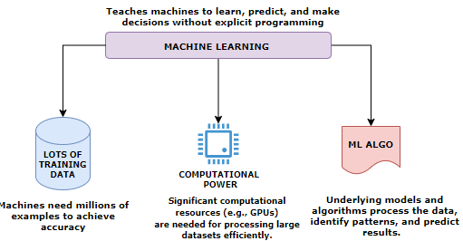

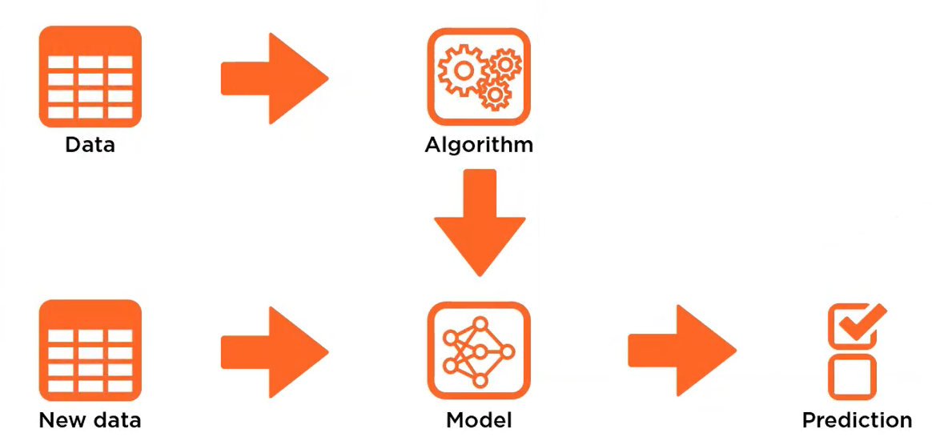

We feed a set of data into a training algorithm 🡪 the algorithm produces a model 🡪then we feed new previously unseen data into that model and the 🡪model will predict what the data represent.

# MACHINE LEARNING TERMINOLOGIES

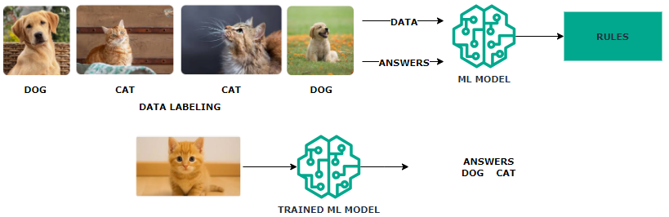

* **Machine Learning Model** learns by extracting patterns from the existing data, establishing rules automatically.
* In above example with multiple images of “dogs” & “cats” we train the model by labeling the training data. This common type of machine learning where the system is trained with labeled data (e.g., pictures of dogs and cats) is called **Supervised Learning**
* After Training the **Trained Model** can be used to classify new, unseen data.
* Machine learning systems adapt to new data without changing the program's code.

## DEEP LEARNING

* Deep learning is a subset of Machine Learning based on neural networks which mimic the structure of human neurons.
* Neural networks consist of multiple computational layers.
* Each layer processes and enhances the data before passing it to the next layer.
* This multi-layer structure improves accuracy for complex tasks (e.g., text generation, image generation).
* *Neural network is the model that generative tools like ChatGPT are also using*.
* **Deep learning** enables models to handle complex inputs (like images or text) and produce complex outputs.

How Neural Networks Work

* + **Input Layer**: Data enters through input neurons.
  + **Processing**: Each neuron performs mathematical operations.
  + **Forwarding**: Neurons pass results to connected neurons.
  + **Hidden Layers**: This process repeats across hidden layers.
  + **Output Layer**: The network generates a prediction.
  + A **deep neural network** has multiple hidden layers, allowing it to learn increasingly abstract features.

Applications

* + Deep learning handles diverse data types: **text, images, audio, video**.
  + Used for tasks like **object detection**, **video segmentation**, and **real-time motion tracking**.
  + Can also generate **synthetic content**.

Limitations

* + **There is limitation of Deep learning when it comes to solving multi‑step problems. To solve these types of problems, we need reinforcement learning.**

### EXAMPLES

1. IMAGE CLASSFICATION SYSTEM

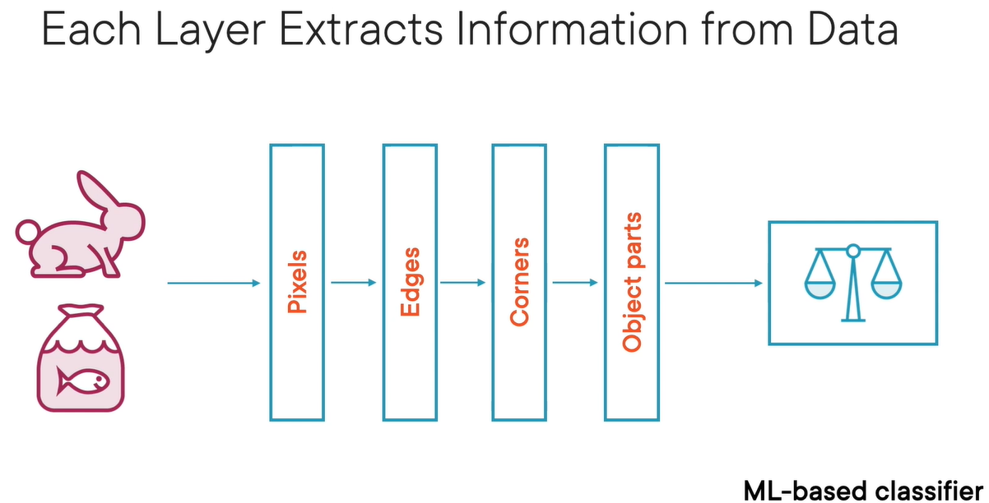

* Different layers of data extract different data from the corpus of data fed into it.
* In the above example of image classification system
  + The first layer extracts the pixels from the image
  + The second layer will put those pixels together to find edges
  + The second layer will put those edges together to find corners
  + The corners put together to view the object (image) and finally we get image recognition/classification

1. Face Recognition
   * Input: Labeled face images.
   * Layer 1: Detects basic lines and edges.
   * Layer 2: Identifies facial features (eyes, nose, mouth).
   * Layer 3: Recognizes full face patterns.
   * Output: Predicts the person’s name.
   * Each layer extracts more complex features than the previous one.

### ADVANTAGES OF DEEP LEARNING

* **Higher Accuracy**: Suitable for solving complex problems.
* **Generative AI Application**: Tools like ChatGPT use deep learning neural networks to enhance text generation accuracy.
* **Utilization of GPUs**: Recent advancements in computational power have made deep learning models more accessible and efficient.

## REINFORCEMENT LEARNING

Reinforcement Learning (RL): Solving Multi-Step Problems

* Reinforcement Learning is a type of machine learning where an agent learns by trial and error to achieve a goal in an environment.

The agent:

* + Observes the environment’s state (e.g., road conditions for a self-driving car)
  + Take actions that change the state (e.g., turning, accelerating)
  + Receives rewards or penalties based on the outcome of its actions
  + Over time, the agent learns which actions lead to better outcomes and refines its strategy.

## GENERATIVE AI

### NLP(NATURAL LANGUAGE PROCESSING)

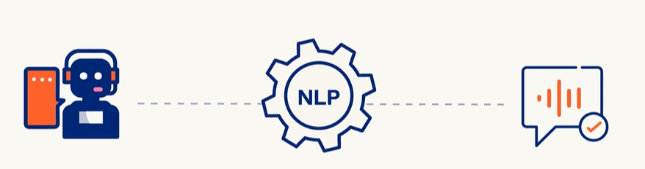

* Enabling and teaching computers to understand, interpret, generate, and respond to human language
* In **Generative AI (GenAI)**, **Natural Language Processing (NLP)** plays a **central role**. GenAI systems like ChatGPT, Bard, Claude, and others are built on advanced NLP techniques to understand and generate human-like language

How NLP Works

Data can be classified as

1. Structured (Sheets/Tables): This type of data is easy to standardize and categorize
2. Unstructured (Audio, Video, Social Media Posts, Email): Difficult standardize and categorize

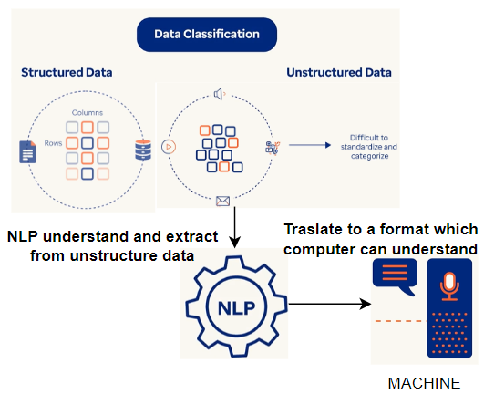

Key Areas of NLP

1. **Text Processing**: Tokenization, stemming, lemmatization, stop-word removal.
2. **Syntax & Parsing**: Understanding grammatical structure.
3. **Semantics**: Understanding meaning and context.
4. **Sentiment Analysis**: Detecting emotions or opinions in text.
5. **Machine Translation**: Translating text between languages.
6. **Speech Recognition**: Converting spoken language into text.
7. **Text Generation**: Creating human-like text (like what I do!).
8. **Named Entity Recognition** (NER): Identifying names, places, dates, etc.
9. **Question Answering & Chatbots**: Building systems that can answer questions or hold conversations.

Challenges in NLP

Syntactic Ambiguity

* **Definition**: When a sentence can be parsed in more than one way due to its structure.
* **Example**: *“I saw the man with the telescope.” 🡪*Did you use a telescope to see the man, or did the man have a telescope?

Lexical Ambiguity

* **Definition**: When a word has multiple meanings.
* **Example**: *“Bank” 🡪* Could mean a financial institution or the side of a river.

Misspellings or Typos

* **Definition**: Errors in spelling that can confuse NLP systems.
* **Example**: *“Recieve”* instead of *“Receive” 🡪*May lead to incorrect parsing or missed keyword matches.

Coreferential Ambiguity

* **Definition**: When it's unclear what a pronoun or noun phrase refers to.
* **Example**: *“John told Tom that he won.”🡪*Who won—John or Tom?

Uncertainty and Idiomatic Ambiguity

* **Definition**: Phrases that are not meant to be taken literally or are vague.
* **Example**: *“Kick the bucket” 🡪* Literally means to kick a bucket, but idiomatically means to die.

Mixing of Languages

* **Definition**: Use of multiple languages in the same sentence or conversation.
* **Example**: *“Mujhe pizza pasand hai, especially with extra cheese.” 🡪* Hindi-English mix (code-switching), common in multilingual societies.

Issues with Social Media Slang Abbreviations

* **Definition**: Informal or abbreviated language used online that may not be in standard dictionaries.
* **Example**: *“LOL”, “BRB”, “SMH” 🡪*These can confuse models not trained on such data.

Inadequate Training Data

* **Definition**: When the model hasn’t seen enough examples of a certain language, dialect, or context.
* **Example**: A chatbot trained only on formal English may struggle with regional slang or dialects.

* **Gen AI is a subset of deep learning, and it uses artificial neural networks to process labeled and unlabeled data using supervised, unsupervised, and semi-supervised methods to generate new content like text, images, videos, or audio.**
* **Unlike conventional AI, Generative AI doesn't just classify or predict data; it generates brand-new content based on its training data.**

* In simple terms, traditional “predictive” machine learning models attempt to learn the relationship between the data and what we want to predict.
* A generative AI model attempts to learn patterns so that it can generate new content.

### CONVENTIONAL (PREDICTIVE) AI VERSUS GENERATIVE AI

**CONVENTIONAL AI**

* Operates by learning from training data and making predictions, classifications, or performing language processing/computer vision.
* Example: Trained on apple images, it tells whether a supplied image is of an apple.

**GENERATIVE AI**

TYPES OF CONTENT GENERATED BY GEN-AI MODELS

* Learning from training data and creating *new* content.
* Example: Trained on apple images, it generates a new apple image not extracted from the training data.

## MACHINE LEARNING MODEL

* This is an object that has been trained beforehand on a dataset. The model can then give output based on input values
* The machine learning object is nothing but a file or set of files. It would have the desired logic that would take in input and spur output data

## MACHINE LEARNING PROCESS

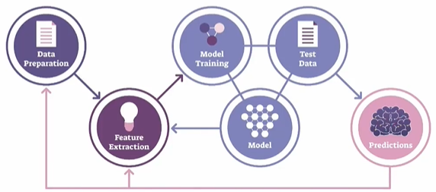

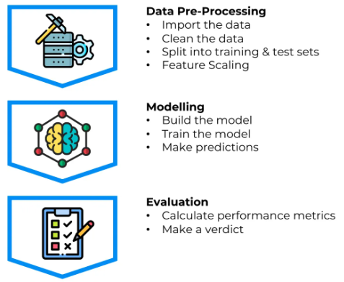

1. **DATA PREPARATION**:
   1. This step involves gathering and cleaning the data to make it suitable for analysis.
   2. It includes tasks like handling missing values, removing outliers, normalizing or standardizing the data, and splitting the data into training and testing sets.
2. **FEATURE EXTRACTION**:
   1. Feature extraction is the process of selecting or creating relevant features from the data that will be used as input for the machine learning model.
   2. It involves identifying the most informative attributes or transforming the data into a more meaningful representation that captures the underlying patterns and relationships.
3. **MODEL TRAINING**:
   1. Model training is the process of using the prepared dataset to teach the machine learning model to recognize patterns and make predictions.
   2. During this step, the model learns from the input data and adjusts its internal parameters to optimize its performance.
4. **MODEL**:
   1. The model is the representation of the learned patterns and relationships from the training data.
   2. It encapsulates the knowledge gained during the training process and can be used to make predictions or decisions on new, unseen data.
5. **TEST DATA**:
   1. Test data is a separate set of data that is not used during the model training. It is used to evaluate the performance of the trained model and measure its accuracy.
   2. The test data should be representative of the real-world scenarios the model will encounter.
6. **PREDICTION**:
   1. Once the model is trained and evaluated, it can be used to make predictions on new, unseen data.
   2. The model takes the input data, processes it using the learned patterns, and generates predictions or decisions based on the trained knowledge.
   3. The accuracy and reliability of the predictions depend on the quality of the model and the suitability of the input data.

## MACHINE LEARNING MODEL AND DATASET

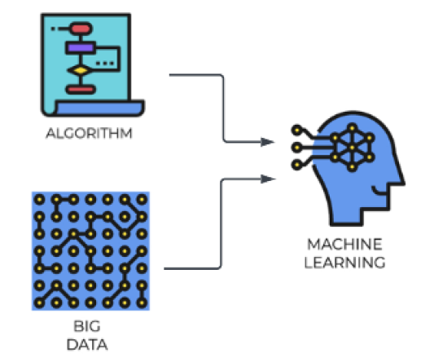

### DATA SET

* A dataset is a collection of structured or unstructured data that is used for analysis, machine learning, or other data-related tasks. It typically consists of multiple data points or instances, where each data point represents an observation or sample.
* A dataset can include various types of data such as numerical, categorical, text, images, or time series.
* Datasets are crucial for training and evaluating machine learning models. They provide the necessary information for the model to learn patterns and relationships.
* Datasets can be sourced from various places, including public repositories, research institutions, or generated internally within an organization
* Common operations on datasets include cleaning, transforming, splitting into training and testing sets, and feature engineering.

### TRAINING SET AND TEST SET

Importance Of Splitting Data Set into a training set and a test set.

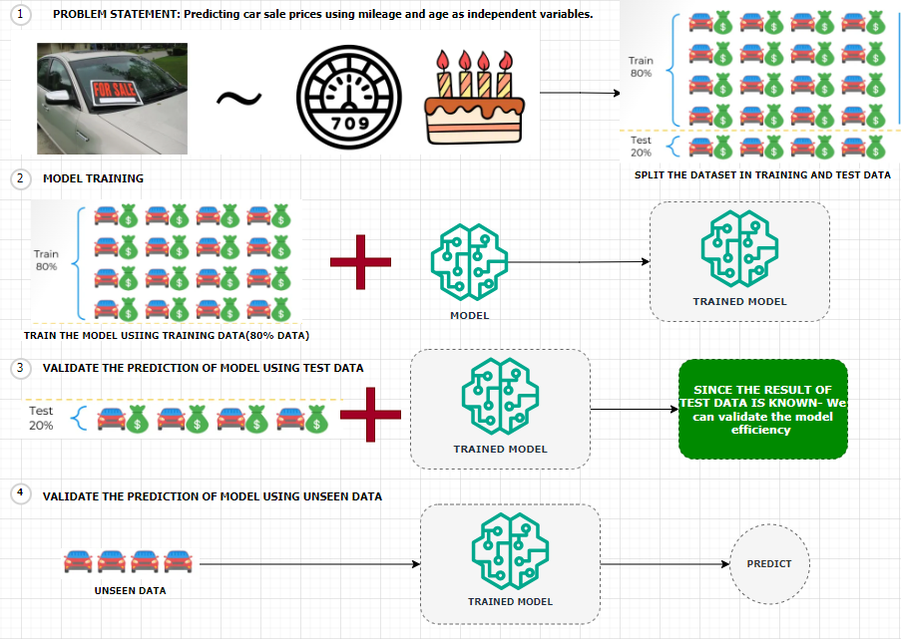

Predicting Car Sale Prices Using Linear Regression

Let’s consider a scenario where we aim to **predict the sale prices of cars** using a **linear regression model**. In this case:

* **Dependent Variable**: Sale price of the car
* **Independent Variables**:
  + Mileage of the car
  + Age of the car

**Dataset Overview**

We are provided with a dataset containing information on **20 cars**. To build and evaluate our model effectively, we split the dataset into two parts:

* **Training Set (80%)**:
  + Contains data for **16 cars**
  + Used to train the linear regression model
* **Test Set (20%)**:
  + Contains data for **4 cars**
  + Set aside before training to evaluate the model’s performance

Model Training and Evaluation

1. **Model Building**:  
   We train the linear regression model using only the training set. This means the model learns the relationship between mileage, age, and sale price from these 16 cars.
2. **Prediction on Test Set**:  
   After training, we apply the model to the 4 cars in the test set. These cars were **not part of the training process**, so the model has **no prior knowledge** of them.
3. **Comparison with Actual Prices**:  
   Since we already know the **actual sale prices** of the test set cars, we can now compare:
   * **Predicted Prices** (from the model)
   * **Actual Prices** (from the dataset)
4. **Model Evaluation**:  
   This comparison allows us to assess how well our model performs on unseen data. Metrics such as **Mean Absolute Error (MAE)** or **Root Mean Squared Error (RMSE)** can be used to quantify the model’s accuracy.

#### EXAMPLE

* Let's say we are building a ML model that can predict the house prices over time. For that we need to have prior information in place about the houses that were already sold over the previous years.
* The information can be the location of the house, the number of rooms, the agent involved in selling the house,

the area in square feet, and what was the price in USD. (as shown in above table)

* To train the model using historical data, we need to select the relevant features/column. ( for example, Agent column is irrelevant for price prediction)
* **This is the historical data is then used to training the ML model. Hence the data like - location, the number of rooms, and the area will become the features. Features are the measurable property within the dataset and the price is going be the label.**

### FEATURES AND LABELS

#### FEATURES

* Features, also known as input variables or independent variables, are the measurable properties or characteristics of the data that are used to make predictions or classifications.
* They represent the input data that the model will analyze and learn patterns from. For example, in the context of predicting house prices, features could include the location, number of rooms, and area of a house.
* Each feature is represented by a specific value or attribute.

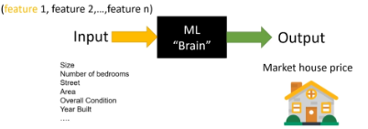

* Selecting the right features is a critical step to ensure the accuracy of ML models, something that is called feature selection.

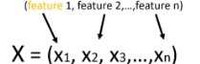

***Mathematically the list of input features will be represented as a vector with the size of N like x1,x2, x3 until Xn***

#### LABELS

* Labels, also known as target variables or dependent variables, are the values that the model aims to predict or classify.
* Labels represent the desired output or outcome based on the input data. In the house price prediction example, the label would be the actual price of the house.
* The model analyzes the provided features and attempts to learn patterns that will help predict or estimate the label.

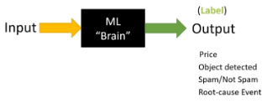

#### FEATURE AND LABELS

|  |
| --- |
| * During the training process, the model is presented with a dataset that contains both the features and the corresponding labels.      * The model learns the relationship between the features and labels by adjusting its internal parameters to minimize the difference between its predicted output and the actual labels. * Once trained, the model can then be used to make predictions or classifications on new, unseen data by analyzing the features and producing a predicted label. * In summary, features are the measurable properties of the data that serve as input for the model, while labels are the desired output or outcome that the model aims to predict or classify. The relationship between the features and labels is learned by the model during the training process. |

**IN A NUTSHELL, the summary is**

|  |
| --- |
| * Building a model to predict house prices over time * Prior information about sold houses including location, number of rooms, agent, area, and price in USD * Training the model using historical data, selecting relevant features and the price as the label * Cleaning the data, removing missing values, and performing feature engineering * Splitting the dataset into training and testing sets, using the training set to train the model and the testing set to evaluate its accuracy * Testing the accuracy and precision of the model by comparing its predictions with the actual values * Deploying the model and allowing users to make predictions based on new input data, such as location, number of rooms, and area. |

## DEEP LEARNING ARCHITECTURE

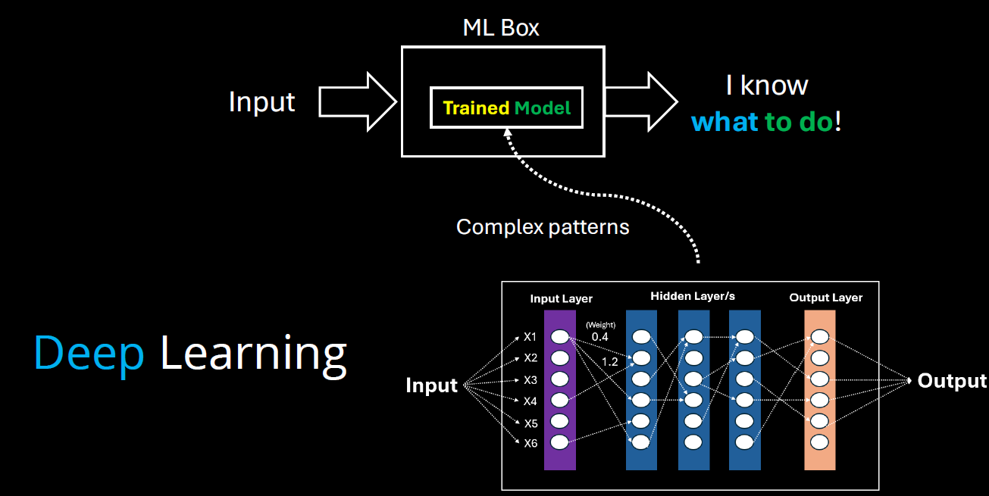

* **Model Training**: In machine learning, training a model means teaching it to recognize patterns in data.
* **Model = Knowledge**: The trained model represents the system’s learned knowledge from the data.
* **Complex Patterns**: When data patterns are too complex for traditional methods, **deep learning** is used.
* **Deep Learning**: Uses **multiple layers** in a neural network to detect and learn complex patterns.
* **Layered Learning**: Each layer in the network captures increasingly abstract features from the data.
* **Evolution of ML**: Deep learning is a more advanced stage in the evolution of model training, enabling machines to handle tasks like image recognition, language understanding, and more.

## DIFFERENT ARCHITECTURE OF DEEP LEARNING

### RECURRENT NEURAL NETWORKS (RNNS)

* RNNs are a type of neural network designed to handle **sequential data** (like text, time series, or speech).
* They are good at remembering **previous inputs** using a concept called **"memory"**, which helps them understand context.

**HOW DO THEY WORK?**

* They process one element at a time in a sequence.
* Each step’s output depends on:
  1. The current input.
  2. The previous step’s output (memory).
* This loop-like structure gives RNNs their “recurrent” nature.

**WHERE ARE RNN USED?**

1. Text generation (e.g., writing like a human).
2. Language translation (e.g., English to Hindi).
3. Speech recognition (e.g., Siri or Google Assistant).
4. Stock price prediction (based on past trends).

### CONVOLUTIONAL NEURAL NETWORKS (CNNS)

* Designed for image and video processing.
* Used in tasks like image classification, object detection, and segmentation.
* Not ideal for language tasks, but powerful in visual domains.

### TRANSFORMER ARCHITECTURE

* **Transformer Architecture is now the standard for generative AI.**
* Processes data in parallel, not sequentially like RNNs → much faster and scalable.
* Uses GPUs (Graphics Processing Units) for efficient training and inference.
* Cloud platforms (AWS, Google Cloud) use GPUs to train large models.
* It makes use of something **Attention Mechanism**

#### ATTENTION MECHANISM

* Like the way we use **colored markers** to highlight important words in a sentence, transformer architecture **focus on key parts** of the input.
* In this architecture – it breaks down the word in multiple tokens called **tokenization**
* Then it calculates the attention **score** of each pair of words to understand relationships between words (e.g., “calculate” is linked to “sum”) – as shown below!
* Hence - using the transformer architecture, the parallel processing coupled with the attention mechanism enables Gen-AI system to digest more data, process it faster, and catch more complex patterns.

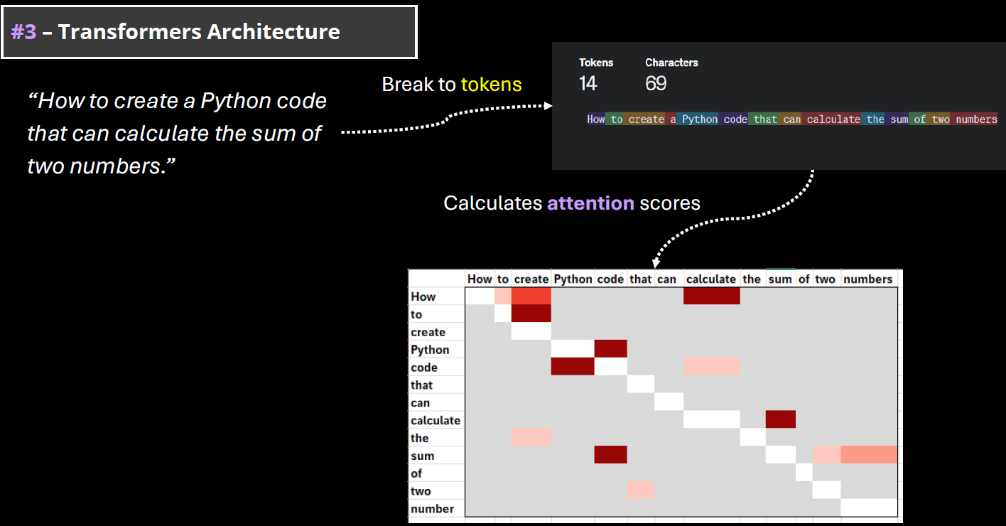

#### WHY TRANSFORMERS MATTER FOR GENERATIVE AI?

* The power of generative AI is based on the capabilities to digest and understand the human language. In machine learning terminology, it is called natural language processing(NLP).
* **Transformer Architecture is helping to train very complex models that can handle the human language. They are called LLMs (large language models)**
* Note: Training an LLM model requires huge amount of data and computing resources.

## FOUNDATION MODEL

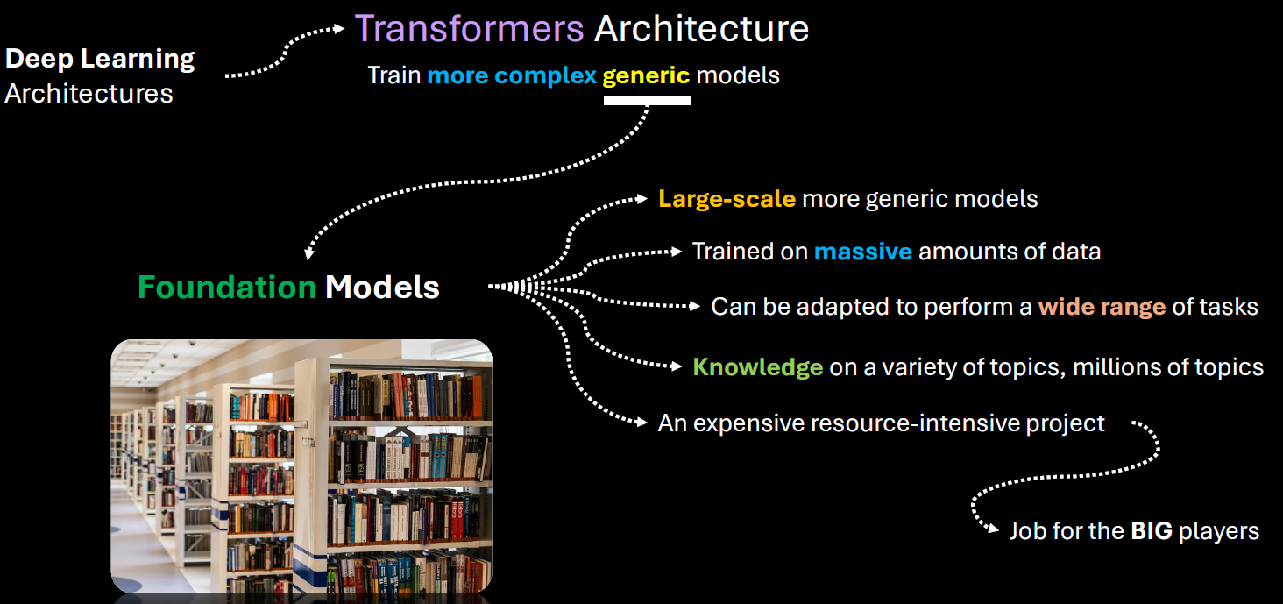

* **Foundation models** are large-scale machine learning models trained on vast amounts of data that can be adapted to a wide range of tasks.
* Training foundation models is expensive and resource-intensive which requires massive data collection, storage, and processing capabilities.
* Needs advanced hardware, software infrastructure, and skilled teams.
* Big tech companies like Google, Microsoft, and Amazon have the resources to train such models.
* **Popular example**: GPT, the foundation model behind OpenAI’s ChatGPT, trained on vast amounts of data

### KEY CHARACTERISTICS

1. **Scale**:  
   Foundation models are typically trained on massive datasets using billions (or even trillions) of parameters. Examples include GPT (like me), BERT, and CLIP.
2. **Generalization**:  
   They are not trained for a single task. Instead, they learn general patterns in data, which allows them to be fine-tuned or prompted for many different tasks—like translation, summarization, image recognition, or even coding.
3. **Multimodal Capabilities**:  
   Some foundation models can handle multiple types of data—like text, images, audio, or video—at the same time. For example, OpenAI’s CLIP can understand both images and text.
4. **Transfer Learning**:  
   Once trained, these models can be adapted to new tasks with relatively little additional data or training, making them highly efficient for downstream applications.

EXAMPLES OF FOUNDATION MODELS

* **GPT (Generative Pre-trained Transformer)** – for natural language understanding and generation.
* **BERT (Bidirectional Encoder Representations from Transformers)** – for understanding the context of words in text.
* **DALL·E** – for generating images from text prompts.
* **CLIP** – for connecting images and text.
* **Whisper** – for speech recognition.

ABOUT GPT

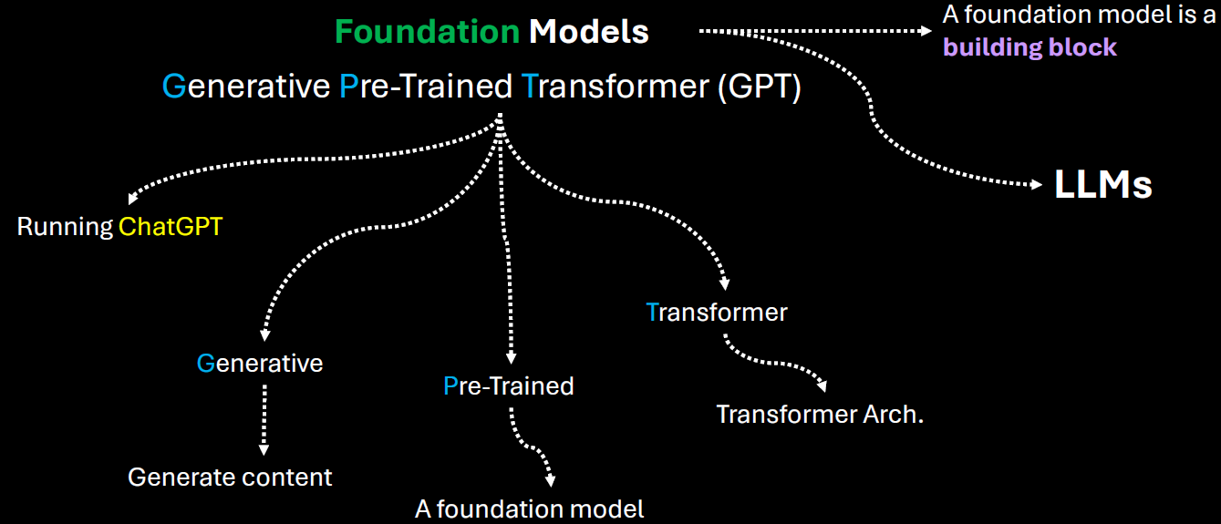

|  |  |
| --- | --- |
| **Generative** | It means that the model can generate content based on the input |
| **Pre-trained** | This model was trained on a large amount of data from diverse sources such as websites, books and articles. |
| **Transformer** | That's the internal architecture of the model, which is becoming the de facto architecture for creating foundation models. |

* Users can directly interact with the model using simple text as a prompt, ask a question and get an answer.
* Given this kind of versatility of a foundation model, smaller players, like medium sized companies or startups can leverage those foundation models developed or and provided by the big players. Hence - Instead of investing millions of dollars in training such models from scratch, they can adapt an existing foundation model for a fraction of that amount and introduce new AI based products more quickly.
* There are many types of foundation models, some focused-on handling natural language processing. Some of them are focused on computer vision tasks like image and video generation, speech recognition etc.
* One of the core foundation model types is for natural language processing. They are called LLMs

## APPLICATION OF GEN-AI

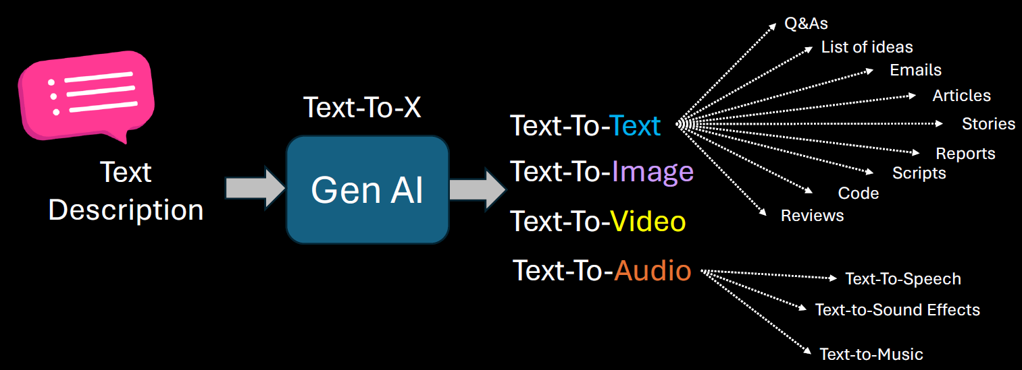

### GEN-AI USE CASES

* 1. Brainstorm Assistant
  2. Summarization
  3. Code Generation
  4. Text Enhancement(e.g. to check for grammatical mistake like copilot in outlook)
  5. Image Generation

## GEN-AI LIMITATIONS & CHALLENGES

**PROMPT SENSITIVITY**

* Generative AI models are highly sensitive to how a prompt is phrased. Small changes in wording can lead to significantly different outputs.
* This can make it difficult to get consistent or desired results without careful prompt engineering.
* **Example:** Asking "Explain climate change simply" vs. "What causes climate change?" may yield different levels of detail or focus.

**KNOWLEDGE CUTOFF**

* Most generative AI models are trained on data available up to a certain point in time. They do not have real-time awareness or access to events or developments after their training cutoff.
* **Implication:** They cannot provide accurate information about recent events, new technologies, or updated regulations unless connected to live data sources.

The solution to this to

1. Retrain the model after regular interval of time
2. Connect the model with online tools

**IT IS NOT DETERMINISTIC**

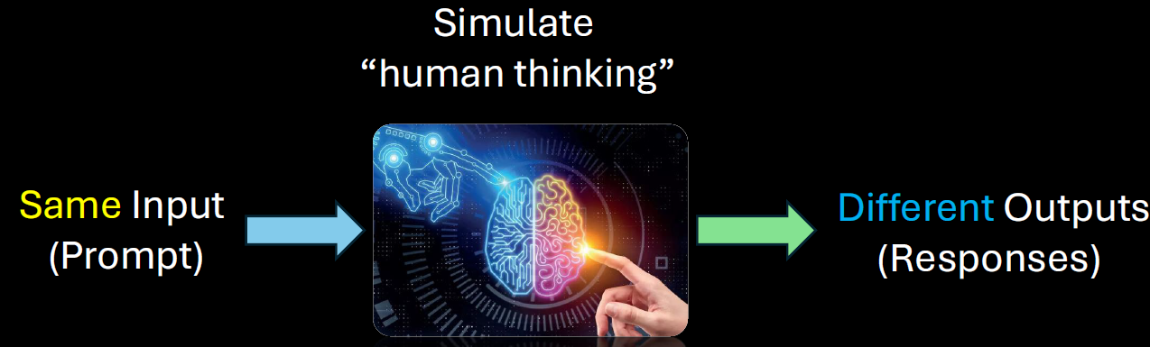

Generative AI is **probabilistic**, not deterministic. This means the same prompt can produce different outputs each time it's run.

**Implication:** This variability can be useful for creativity but problematic for tasks requiring consistency and repeatability.

**STRUCTURED DATA**

* Generative AI struggles with tasks that require precise manipulation of structured data (like databases, spreadsheets, or complex logic).
* **Example:** It may misinterpret or incorrectly summarize tabular data or fail to follow strict formatting rules.

**HALLUCINATIONS**

* AI models can "hallucinate" — confidently generating false or misleading information that sounds plausible.
* **Example:** Citing non-existent research papers or inventing facts in a historical summary.

**LACK OF COMMON SENSE**

* Despite being trained on vast data, generative AI lacks **true understanding** or **common-sense reasoning**. It may fail at tasks that require intuitive knowledge or real-world logic.
* **Example:** It might suggest putting metal in a microwave or confusing cause and effect in a scenario.

**BIAS AND FAIRNESS**

* AI models can reflect and even amplify biases present in their training data. This can lead to unfair, offensive, or discriminatory outputs.
* **Example:** Gender or racial bias in job recommendations or stereotypical characterizations in generated content.

**DATA PRIVACY, SECURITY, AND MISUSE**

* Generative AI can inadvertently expose sensitive information if trained on private data. It can also be misused for harmful purposes like generating fake news, phishing emails, or deepfakes.
* **Concerns:**
  + **Privacy:** Leaking personal or proprietary data.
  + **Security:** Being used to craft convincing scams.
  + **Misuse:** Generating harmful or misleading content.

# TYPES OF ML MODELS

1. **TRADITIONAL MODEL**
2. **REPRESENTATIONAL ML MODEL**

## TRADITIONAL MACHINE LEARNING MODELS

These models rely on **manually engineered features** and are often simpler and more interpretable. They include:

**CHARACTERISTICS OF TRADITIONAL ML MODEL**

1. Require **feature extraction** and **preprocessing** by humans.
2. Perform well on **structured data** (like tables, spreadsheets).
3. Easier to interpret and debug.
4. Often faster to train and require less data.

**EXAMPLES**

* **Linear Regression**
* **Logistic Regression**
* **Decision Trees**
* **Random Forests**
* **Support Vector Machines (SVM)**
* **K-Nearest Neighbors (KNN)**
* **Naive Bayes**

## REPRESENTATIONAL (OR REPRESENTATION LEARNING) MODELS

Representation ML based systems figure out by themselves what features to pay attention to

**CHARACTERISTICS OF REPRESENTATIONAL ML MODEL**

* Learn **significant features from the underlying data**
* Often based on **deep learning** architectures.
* Require large datasets and computational power.
* Less interpretable but more powerful for complex tasks.

**EXAMPLES:**

* **Neural Networks (NNs)**
* **Convolutional Neural Networks (CNNs)** – for images
* **Recurrent Neural Networks (RNNs)** – for sequences
* **Transformers** – for text and more
* **Autoencoders**
* **Self-supervised learning models**

# CHOOSING THE RIGHT ML SOLUTION

Broad Categories of Machine Learning Problems

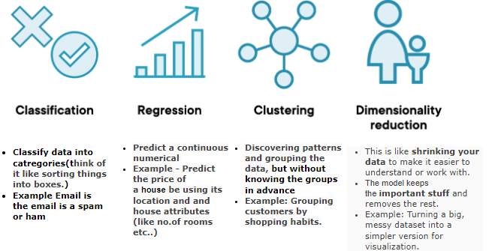

# HOW MACHINE LEARNS

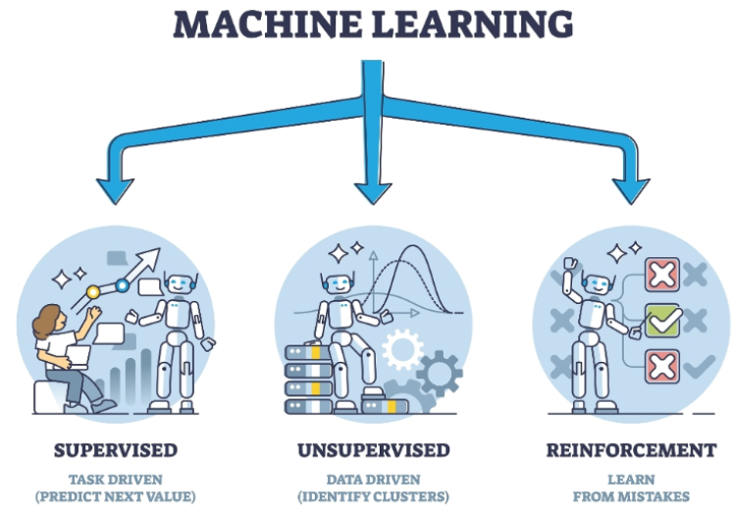

1. **SUPERVISED LEARNING MODELS**
   1. In supervised learning, for training data set that we feed in the features along with the labels(output)
2. **UNSUPERVISED LEARNING MODELS**:
   1. In unsupervised learning – we don’t know what the output will be, hence we cannot provide labels in training data
   2. Here we just want the model to split our data into different groups or clusters.

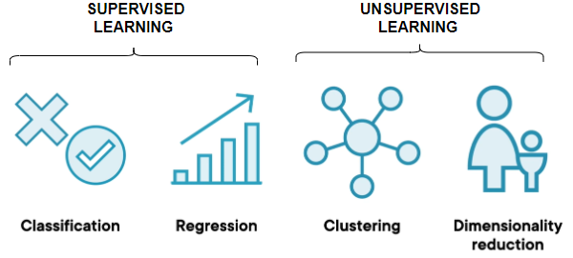

1. **REINFORCEMENT LEARNING MODELS**:
   1. These models learn through interaction with an environment. They receive feedback in the form of rewards or penalties, allowing them to learn optimal strategies for decision-making.
   2. Example:
      1. Let's take the example where we trying to teach a system how to play a game of chess against a human. So now, instead of we feeding in data about the different chess moves, we ask the model to play against a human.
      2. Hence, the system would go ahead and make a set of moves, and let's say it loses. So now it understands that if it performs set of actions, it results in a loss, then the next time around it will go and change its actions.
      3. It'll keep on doing this, so it's performing reinforcement of its actions. At the end when it does win a game, that’s the reward. So now it understands that based on certain set of actions that it takes, it's going to get a reward.

## SUPERVISED LEARNING

* The name supervised learning originates from the idea that training a machine while using this type of approach is like how humans are learning under the supervision of a teacher.
* Example - In regular school class, we have a group of students and a teacher. During a lecture about some specific topic, the teacher will provide several examples while teaching something. The students will use those examples to analyze and memorize them, something that will help them to extract the patterns from those examples. At a later stage, based on the information provided, the students will be able to solve similar problems. Overall, the teacher decided what kind of examples to present and how many, he or she basically supervised the learning process.
* **In supervised learning, we train machines by providing them with a set of examples, each provided example is a pair consisting of an input object and the desired output value for that object, it’s called label data set.**

|  |  |
| --- | --- |
|  | * **"X" is the input into the machine which can be a group of values called "features".** * **"Y" is the output of that machine, the target value.** * **Functions with the input x are basically some mathematical transformation function or mapping function discovered by the algorithm doing the training process** |

**NOTE: In Supervised Machine learning – the model tries to find the mapping function to map the input (feature) and output(label)**

|  |  |  |  |  |  |  |  |  |
| --- | --- | --- | --- | --- | --- | --- | --- | --- |
| **RELATION BETWEEN MAPPING FUNCTION AND ML ALGORITHM**  **WHAT IS A MAPPING FUNCTION?**   * Think of a mapping function as a recipe or rule that tells us how to turn input into output. * In machine learning, this function is what the algorithm is trying to learn from data.   **REAL-WORLD EXAMPLE: PREDICTING HOUSE PRICES:** Let’s say we want to predict the price of a house based on its size.   * Input (X): Size of the house (e.g., 1000 sq ft) * Output (Y): Price of the house (e.g., ₹50 lakhs)   The ML algorithm’s job is to learn a function like:  **Price = f(Size)**  This function could be:   * A straight line (if price increases steadily with size) * A curve (if price increases faster for bigger houses)   **HOW ML ALGORITHM USES THE MAPPING FUNCTION?**   1. **Step 1**: We give it data: Sizes and prices of many houses. 2. **Step 2**: It finds a pattern: Learns the best function (mapping) that connects size to price. 3. **Step 3**: We use it to predict: For a new house size, it uses the function to predict the price.   Example in Simple Terms (Training Data)   |  |  | | --- | --- | | Size (sq ft) | Price (₹ lakhs) | | 1000 | 50 | | 1500 | 75 | | 2000 | 100 |  * The ML algorithm might learn: **Price = 0.05 X Size** * So, for a 1200 sq ft house: **Price = 0.05 X 1200 = ₹60** * A mapping function is the rule that connects input to output. * An ML algorithm learns this rule from data. * Once learned, it can make predictions on new data.   **Here's a simple chart that shows how a machine learning algorithm learns a mapping function from house size to price:**     * *Blue dots: Real data points (house size vs. price).* * *Red line: The learned function (Price = 0.05 × Size), which the ML algorithm uses to make predictions***.**   **This is a basic example of how ML finds a pattern (a mapping function) in data and uses it to predict outcomes.** |

Two typical tasks performed by Supervised Learning

1. **CLASSIFICATION**
2. **REGRESSION**

### CLASSIFICATION (BINARY CLASSIFICATION)

**Classification** is a type of supervised learning where the goal is to **predict a category or class**. Instead of predicting a number (like in regression), classification predicts a **label**.

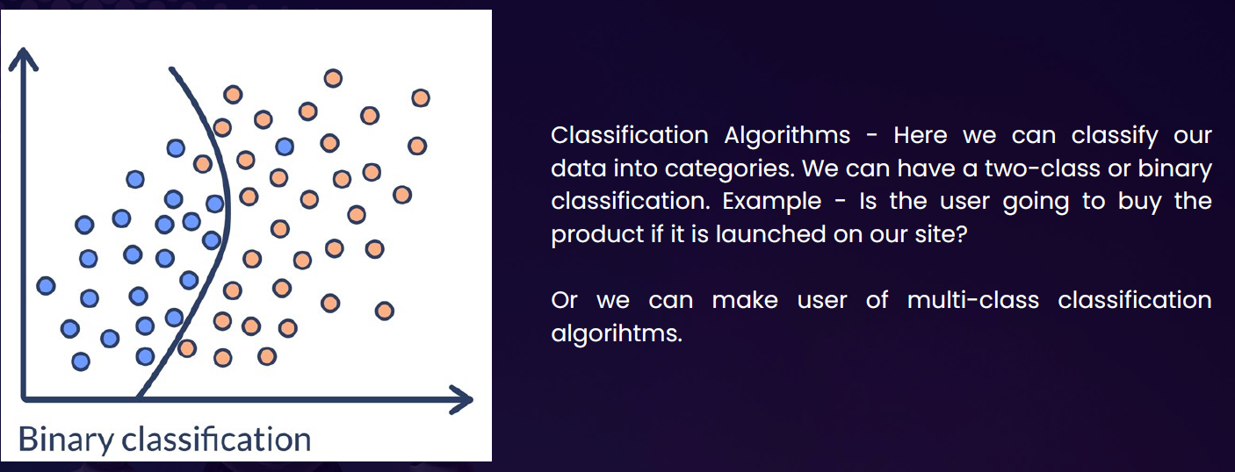

**Real-Life Example: Email Spam Detection**

Imagine if we have a bunch of emails, and each one is labeled as either:

* **Spam**
* **Not Spam**

We train a machine learning model with this data. The model learns patterns like:

1. Emails with “win money” → likely spam
2. Emails from your contacts → likely not spam

Once trained, the model can classify **new emails** as spam or not spam.

**Other Examples of Classification**

|  |  |
| --- | --- |
| Problem | Classes (Labels) |
| Disease diagnosis | Sick / Healthy |
| Image recognition | Cat / Dog / Bird |
| Customer feedback sentiment | Positive / Negative / Neutral |
| Loan approval | Approved / Rejected |

#### MULTICLASS CLASSIFICATION

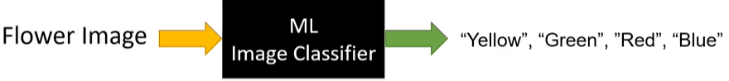

Multiclass classification is when a machine learning model predicts **one label out of three or more possible categories**.

|  |  |
| --- | --- |
| **Problem** | **Classes (Labels)** |
| Handwritten digit recognition | 0 to 9 |
| Animal image classification | Cat / Dog / Bird / Horse |
| Exam grading | A / B / C / D / F |

* SVM(Support Vector Machines) are one such classification ML Model

### REGRESSION ALGORITHM

* **Regression** is a type of **supervised learning** where the goal is to **predict a continuous value** (a number) based on input data.

**Real-World Example: Predicting House Prices**

|  |  |  |  |  |  |  |  |  |  |  |  |  |  |  |  |  |  |  |  |  |  |
| --- | --- | --- | --- | --- | --- | --- | --- | --- | --- | --- | --- | --- | --- | --- | --- | --- | --- | --- | --- | --- | --- |
| Imagine a real estate agent and want to **predict the price of a house** based on certain features like:   * Size of the house (in square feet) * Number of bedrooms * Location * Age of the house | You collect data from past house sales. Each row in your dataset looks like this:   |  |  |  |  |  | | --- | --- | --- | --- | --- | | **Size (sqft)** | **Bedrooms** | **Age (years)** | **Location Score** | **Price (₹)** | | 1200 | 3 | 5 | 8 | 45,00,000 | | 1500 | 4 | 2 | 9 | 60,00,000 | | 1000 | 2 | 10 | 6 | 35,00,000 | |

* Now, we can train a **regression model** using this data. The model learns the relationship between the features and the price. Later, when we get a new house with known features but unknown price, the model can **predict the price**.

Great question! Let's break it down simply.

**What Does "Predict a Continuous Value" Mean?**

A **continuous value** is a number that can be **any value within a range**, not just fixed categories.

So, when we say **"predict a continuous value"**, we mean the model is trying to **guess a number** — not a label like "yes/no" or "cat/dog", but something like:

**Real-Life Examples**

|  |  |  |
| --- | --- | --- |
| **Problem** | **Input Features** | **Output (Continuous Value)** |
| Predict house price | Size, location, age | ₹50,00,000 |
| Predict temperature | Date, time, humidity | 32.5°C |
| Predict height of a child | Age, gender, parents' height | 145.2 cm |
| Predict fuel efficiency | Engine size, weight, speed | 18.7 km/l |

In each case, the **output is a number** that can vary smoothly — not just a fixed set of options.

**GRAPHICAL REPRESENTATION**

* Each dot represents a house.
* The x-axis is the size of the house (in square feet).
* The y-axis is the price of the house (in INR).
* The pattern shows that as house size increases, the price also tends to increase — this is the kind of relationship a regression model learns.
* Red line: The regression line — this is the model's prediction of house price based on size.
* The most common form of regression analysis is linear regression

#### LINEAR REGRESSION

* **Linear regression** is a fundamental concept in statistics and machine learning used to model the relationship between a **dependent variable** (target) and one or more **independent variables** (predictors or features).
* **Key Idea:** Linear regression assumes that there is a **linear relationship** between the input (X) and output (Y), meaning:

|  |  |
| --- | --- |
| **Y = aX + b + error** | * **Y** is the dependent variable (what we want to predict), * **X** is the independent variable (input), * **a** is the slope (how much Y changes with X), * **b** is the intercept (value of Y when X = 0), * **error** is the difference between the predicted and actual value. |

##### TYPES OF LINEAR REGRESSION

1. **Simple Linear Regression**: 1 independent variable: **Y = aX + b**
2. **Multiple Linear Regression**: more than 1 independent variable **Y = a1X1 + a2X2 + ... + anXn + b**

|  |
| --- |
| **Goal: Find the best values of a and b so that the predicted Y values are as close as possible to the actual Y values — usually by minimizing the mean squared error (MSE) between them.** |

**Other Applications:**

* Predicting sales based on ad spend
* Estimating house prices based on size, location, etc.
* Forecasting trends over time

##### EXAMPLE OF LINEAR REGRESSION

|  |  |  |
| --- | --- | --- |
| Problem: You have data showing how much a student studies (in hours), and their exam score. You want to predict the score based on study time. | **Study Hours (X)** | **Exam Score (Y)** |
| 1 | 50 |
| 2 | 55 |
| 3 | 65 |
| 4 | 70 |
| 5 | 75 |

**Goal:** Find a line Y = aX + b that best fits this data.

**Step 1: Plot the data :** If you plot X and Y on a graph, you'll notice a roughly straight-line trend.

**Step 2: Apply linear regression :** Using Python (with scikit-learn), you can fit a model:

|  |  |
| --- | --- |
| **from sklearn.linear_model import LinearRegression**  **import numpy as np**  **# Data**  **X = np.array([[1], [2], [3], [4], [5]]) # 2D array for sklearn**  **Y = np.array([50, 55, 65, 70, 75])**  **# Model**  **model = LinearRegression()**  **model.fit(X, Y)**  **# Coefficients**  **slope = model.coef_[0]**  **intercept = model.intercept_**  **print(f"Model: Y = {slope:.2f}X + {intercept:.2f}")** | **Output:**  Model: Y = 6.5X + 43.0  This means:   * For every extra hour studied, score increases by ~6.5 * If a student studies **0 hours**, expected score = 43   **Prediction Example:**  Predict the score if a student studies for 6 hours:  **model.predict([[6]]) # Output: ~82.0**  So, **predicted score = 82**. |

## UNSUPERVISED LEARNING

* **Unsupervised learning** is a type of machine learning where the model learns from data **without any labels**.
* It tries to find **patterns, structures, or groupings** in the data on its own.

##### Examples

Imagine we have a bunch of photos of animals, but we don’t tell the model which ones are cats, dogs, or birds. The model looks at the photos and **groups similar ones together** — maybe all the cats in one group, dogs in another, and so on.

Common Use Cases

|  |  |
| --- | --- |
| Use Case | Description |
| Customer Segmentation | Grouping customers based on behavior or preferences. |
| Market Basket Analysis | Finding which products are often bought together. |
| Anomaly Detection | Spotting unusual patterns (e.g., fraud detection). |
| Document Clustering | Grouping similar news articles or research papers. |
| Image Compression | Reducing image size by identifying patterns in pixels. |

Popular Algorithms

* **K-Means Clustering**
* **Hierarchical Clustering**
* **DBSCAN**
* **Principal Component Analysis (PCA)**
* **Autoencoders**

## SUPERVISED V/S UN-SUPERVISED LEARNING

# SPECIALIZED ML PROBLEMS

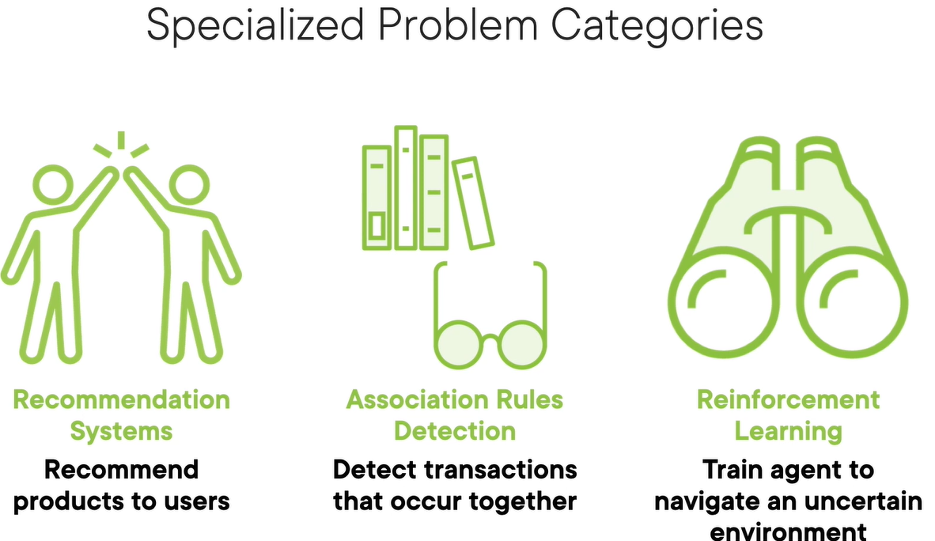

|  |  |
| --- | --- |
| Recommendation System | * Recommend products which user might lik e * Typically used in E-commerce application |
| Association Rule Detection | * Detect transaction that can occur together * For example – **"If a customer buys Bread and Butter, they are likely to buy Milk** |
| Reinforcement Learning | * Robots learn to walk. |

## RECOMMENDATION SYSTEMS

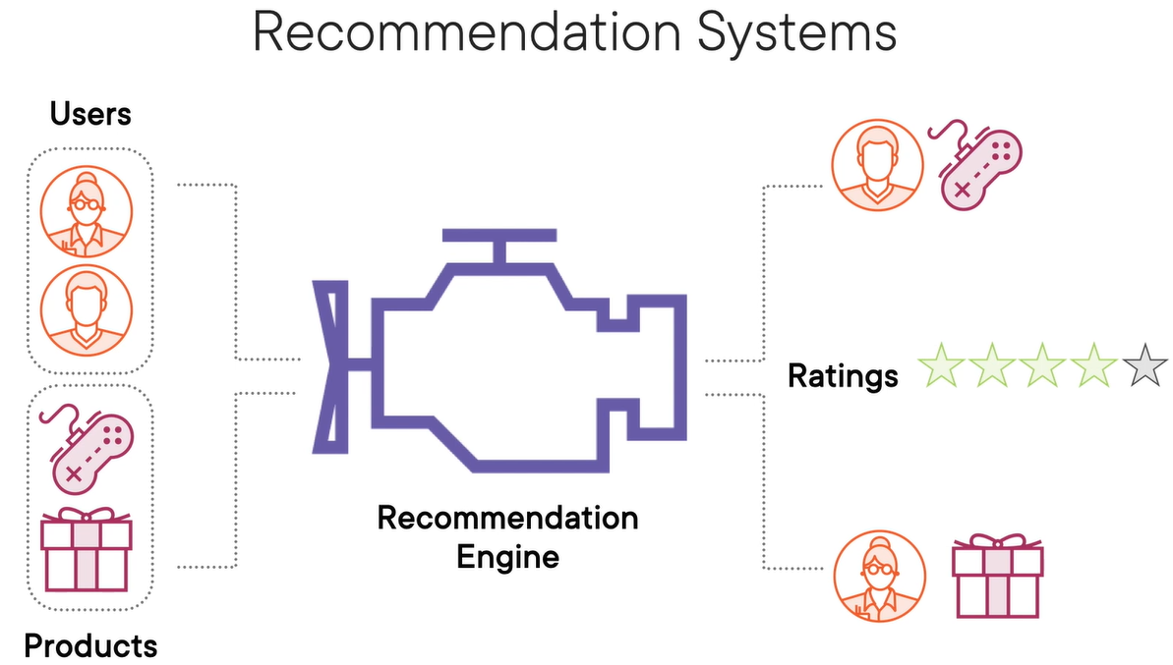

* A **Recommendation System** is a type of information filtering system that predicts and suggests items a user might like based on various data inputs.
* These systems are widely used in platforms like Netflix, Amazon, Spotify, and YouTube.

### TYPES OF RECOMMENDATION SYSTEMS

#### CONTENT-BASED FILTERING

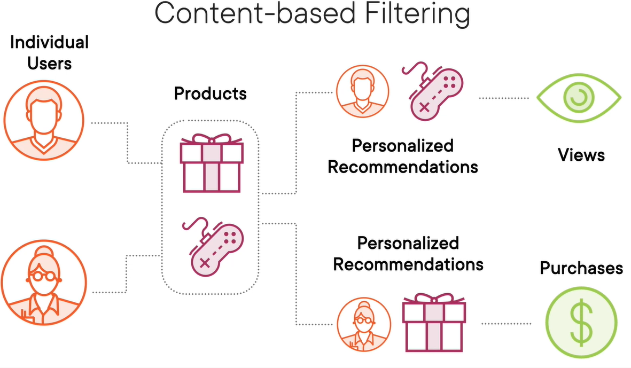

* For any typical e-commerce site has large number user. This user will have history of brought and viewed products
* Based on user’s history and product characteristics can used to figure out – user will like a product or not – based on which a product is recommended.
* Items are recommended based on user profile , product features or items similar to those the user liked in the past.
  + Other Typical Example Based on item features (e.g., genre, keywords). If we watched many action movies, it recommends more action movies.

#### COLLABORATIVE FILTERING

* In a typical ecommerce platform there are certain user who are buying product and other set of users who are buy, like and reviewing the same product. Collaborative filtering techniques make use of this information.
* Recommend items based on the preferences of similar users.
  + Two types:
    - **User-based**: "Users like you also liked…"
    - **Item-based**: "Users who liked this item also liked…"
  + Example: Amazon’s “Customers who bought this also bought…”

#### HYBRID SYSTEMS

* + Combine content-based and collaborative filtering.
  + More accurate and robust.

Example Scenario: Movie Recommendation

|  |  |  |  |  |  |  |  |  |  |  |  |  |  |  |  |  |
| --- | --- | --- | --- | --- | --- | --- | --- | --- | --- | --- | --- | --- | --- | --- | --- | --- |
| Let’s say a user has rated the following movies:   | **Movie** | **Genre** | **User Rating** | | --- | --- | --- | | Inception | Sci-Fi | 5 | | Interstellar | Sci-Fi | 5 | | The Notebook | Romance | 2 | | Titanic | Romance | 3 | | A **content-based system** might recommend more Sci-Fi movies like *The Matrix* or *Blade Runner*.  A **collaborative filtering system** might find other users who rated *Inception* and *Interstellar* highly and suggest movies they also liked. |

## ASSOCIATIONS RULES DETECTION

* **Association Rule Detection** is a data mining technique usually used to identify interesting relationships, patterns, or associations among a set of items in large datasets.
* It's commonly used in market basket analysis to find products that frequently co-occur in transactions.
* **It’s a rule based machine learning technique, where ML is used to create rules**
  + The rules are in the form “if x then y” e.g. If the shopping card has books its likely to contain stationaries
  + Association rule learning tries to identify strong rules which are supported by probability i.e. if the presence of “x” means there is high probability of “y”.
  + These strong rules can be extremely useful in
    - Recommendations
    - Cross-sell or Up-sell the produts

Key Concepts

* **Support**: How frequently an itemset appears in the dataset.
* **Confidence**: How often do items in Y appear in transactions that contain X.
* **Lift**: The ratio of observed support to that expected if X and Y were independent.

Example: Market Basket Analysis

Imagine a supermarket wants to analyze customer purchase behavior. Here's a sample dataset of transactions. **Goal: Find rules like "If a customer buys Bread and Butter, they are likely to buy Milk."**

|  |  |  |  |  |  |  |  |  |  |  |  |  |  |
| --- | --- | --- | --- | --- | --- | --- | --- | --- | --- | --- | --- | --- | --- |
| | Transaction ID | Items Bought | | --- | --- | | 1 | Milk, Bread, Butter | | 2 | Bread, Butter | | 3 | Milk, Bread | | 4 | Milk, Bread, Butter, Eggs | | 5 | Bread, Butter, Eggs | | Step-by-Step Rule Detection  Let’s say we want to evaluate the rule:**{Bread, Butter} ⇒ {Milk}**   1. Support = Transactions with Bread, Butter, and Milk / Total Transactions = 2 / 5 = 0.4 2. Confidence = Transactions with Bread, Butter, and Milk / Transactions with Bread and Butter = 2 / 3 = 0.67 3. Lift = Confidence / Support of Milk = 0.67 / 0.6 = 1.11   **Since Lift > 1, the rule suggests a positive association between {Bread, Butter} and {Milk}.** |

## REINFORCEMENT LEARNING

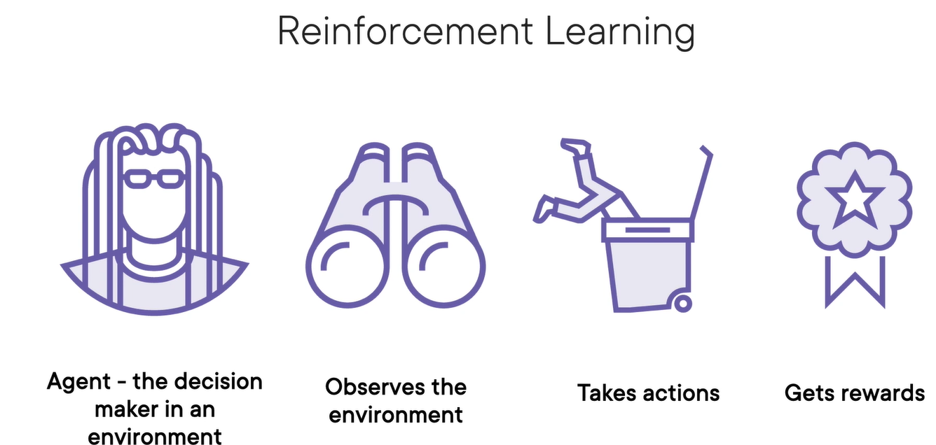

**Reinforcement Learning (RL)** is a type of machine learning where an agent learns to make decisions by interacting with an environment to maximize some notion of cumulative reward.

|  |
| --- |
| STEP TO TRAIN MODEL   * We train the agent in a computer simulation, which acts as a virtual sandbox for the real‑world environment. * Then, we fine tune the agent's behavior in a safe, real‑world environment to iron out any training issues. * Finally, we deploy the agent into the real world while we monitor its behavior and collect new data to further improve the model |

How It Works (The RL Loop)

|  |  |
| --- | --- |
|  | 1. The agent is the decision in an environment which has to constantly looking around and observe the **current state/environment**. The environment is completely new for Agent 2. It takes certain **actions** in the environment. 3. If these actions happen to be a right one agent will be rewarded or otherwise penalized. 4. The output of Reinforced learning is set of action rather than set of predictions 5. The algorithm that determines these action is called **policy** 6. Actions are optimized to earn rewards and avoid punishments |

Example: Game Playing (e.g., Tic-Tac-Toe)

1. **State**: Current board configuration.
2. **Action**: Place X or O in an empty cell.
3. **Reward**: +1 for win, -1 for loss, 0 for draw.
4. **Goal**: Learn a policy that maximizes the chance of winning.

Real-World Applications

1. **Robotics**: Teaching robots to walk or grasp objects.
2. **Finance**: Portfolio optimization.
3. **Healthcare**: Personalized treatment strategies.
4. **Games**: AlphaGo, OpenAI Five, etc.
5. **Recommendation Systems**: Dynamic content personalization.

# APPLYING ML IN COMPLEX DATA

|  |  |
| --- | --- |
| Applying ML To Text Data  (NLP) | We apply ML for text in following use-cases   * Sentiment analysis of reviews on a site * Spam filtering * Language Translation * Natural Language Processing |
| Applying ML To Image Data  (CNN - convolutional neural networks) | We apply ML for image in following scenarios   * Image Classification * Object Detection * Facial recognition * Visual Search Engines * Medical imaging |
| Applying ML To Speech Data | We apply ML for image in following scenarios   * Speech Recognition * Speech to text conversion * Personalized Voice Assistants |

## APPLYING ML TO TEXT DATA

Why Text Needs Preprocessing?

* ML models work with **numbers**, not raw text.
* Text must be **converted into numeric form** before feeding into a model.

Steps to Prepare Text for ML

Step 1: Treat each sentence as a **document**.

* **Step 2: Tokenize** the document into individual words.
* **Step 3: Numerically encode** each word (e.g., X₀, X₁, …, Xₙ).
* **Step 4:** Combine encoded words into a **tensor** (multi-dimensional array).

### ENCODING TECHNIQUES

**There are various techniques to encode the text to numbers**

#### ONE-HOT ENCODING

What is One-Hot Encoding?

* One-hot encoding is a technique to convert **text data into numerical format** so that it can be used in machine learning models.  
  Each **unique word** in the text is represented as a **binary vector**:
* 1 indicates the presence of the word.
* 0 indicates absence.

Example

|  |  |
| --- | --- |
| Let’s say we have a small corpus of 3 reviews: | **"Amazing movie"**  **"Worst movie ever"**  **"Two thumbs up"** |
| **Step 1: Build the Vocabulary** | All unique words across the reviews:  ["Amazing", "movie", "Worst", "ever", "Two", "thumbs", "up"] |
| **Step 2: One-Hot Encode Each Review** | * **One-hot encoding** is like giving each word a unique ID in binary form * Each position in the vector corresponds to a word in the vocabulary.  | **Review** | **One-Hot Vector** | | --- | --- | | Amazing movie | [1, 1, 0, 0, 0, 0, 0] | | Worst movie ever | [0, 1, 1, 1, 0, 0, 0] | | Two thumbs up | [0, 0, 0, 0, 1, 1, 1] | |

Limitations

* **No word order** is preserved.
* **No semantic meaning** is captured (e.g., “good” and “great” are unrelated).
* Vectors can become **very large** with big vocabularies.

#### FREQUENCY-BASED ENCODING

What is Frequency-Based Encoding?

A method to convert text into numerical form by **counting how often words appear** in documents or across a corpus.

---

### 🔸 **Common Techniques**

#### 1. **Count Vector**

- Each document is represented as a vector of **word counts**.

- Simple but doesn’t account for word importance across documents.

#### 2. **TF-IDF (Term Frequency–Inverse Document Frequency)**

- Balances **how often a word appears in a document** with **how rare it is across all documents**.

- Formula:

$$ \text{TF-IDF}(i, j) = \text{TF}(i, j) \times \text{IDF}(i) $$

- **TF(i, j)**: Frequency of word *i* in document *j*.

- **IDF(i)**: Inverse frequency of word *i* across all documents.

#### 3. **Co-occurrence Matrix**

- Captures how often words appear **together** in a context window.

- Useful for understanding **word relationships**.

---

### 📝 **Example (TF-IDF)**

Corpus:

- Doc 1: "The movie was awesome"

- Doc 2: "The movie was terrible"

- **TF** for "movie" in Doc 1 = 1

- **IDF** for "movie" = low (appears in both docs)

- **TF-IDF** for "awesome" = high (unique to Doc 1)

---

### ✅ **Advantages**

- Captures **importance** of words.

- More informative than one-hot encoding.

### ⚠️ **Limitations**

- Still **ignores word order**.

- Doesn’t capture **semantic meaning** like embeddings.

#### PREDICTION-BASED ENCODING (WORD EMBEDDINGS)

* Learns **semantic relationships** between words.
* Words used in similar contexts have **similar vectors**.
* Examples: Word2Vec, GloVe, FastText.
* Captures meaning like:
  + *King – Man + Woman ≈ Queen*
  + *Paris : France :: London : England*
* Requires **large corpus** and **unsupervised learning**.

**🔹 Key Takeaways**

* Text must be **numerically encoded** for ML models.
* Choose encoding based on:
  + Simplicity → One-Hot
  + Importance → TF-IDF
  + Meaning → Word Embeddings

## APPLYING ML TO IMAGE DATA

## APPLYING ML TO SPEECH DATA